**Office Administrator**

Based in Goma Office (DRC)

**Job Description**

**Job Purpose**

* To be responsible for providing efficient and effective administration to CAFODs programme and Office in Goma/DRC
* Liaise with internal and external contacts providing information as needed
* Provide general office support, keeping log of petty cash, and ensuring buildings and premises are maintained.

**Job Scope**

* No responsibilities for budget and money, but has petty cash responsibility (small allocation to manage)
* Carries out task management of staff of Grade 2 and below

**Accountability**

This role reports to the Finance and Office Manager.

**Key responsibilities**

**Ensure effective and efficient administrative and support functions (45%):**

* Providing logistical support to Programme Finance Officer in respect of the preparation of workshops / other programme activities and any other administrative and logistical arrangements as required;
* Setting up meetings, booking venues and arranging vehicles as needed
* Attend meetings and take minutes if required
* Ensure sufficient supplies of CAFOD resources, stationary etc for the use of office staff.
* Maintain effective office records (Vehicles, Insurance, legal agreements and correspondence).
* Maintain files (paper and electronic) archiving old documentation as needed.
* Ensure office handbooks, processes, policies and procedures are disseminated to all staff as needed and source documents are stored in all user files
* Maintain records of key dates i.e. expiry of agreements, contracts etc. and inform relevant managers.
* Hold a petty cash float and record all payments according to Financial Procedures documents
* Ensure provision of relevant insurance cover (office, vehicle, personal accident), obtaining quotes and renewing cover annually.
* Maintain and Oversee office inventory and Cross check vehicles functioning (Maintenance book/files; fuels records and reports; office furniture and equipment’s)
* Oversee the work of other support staff including drivers, cleaners etc to ensure smooth running of support functions

**Liaise with internal and external contacts (20%):**

* Deal with enquiries, answer incoming phone calls and take messages if necessary.
* Liaise with visitors including arranging visits from overseas staff, providing information on how to find the office, national entry requirements, assisting to obtain visas
* Organize travel arrangements for visitors and staff (tickets, insurance, security processes, accommodation, airport, visa formalities, etc.)
* Provide relevant information to visitors and callers
* Welcoming visitors, and referring them to the appropriate staff
* Keeping track of staff and visitors on the premises
* Keeping the reception area tidy and welcoming
* Receiving and ordering deliveries and taxis as requested by staff members and visitors.

**Financial Administration (25%):**

* Keep log of petty cash income and expenditure and record all payments according to Financial Procedures documents
* Delivery of documents and letters around town and paying bills as requested by the line manager.
* Minor purchasing as necessary, particularly in procurement of office supplies.
* Perform any general chores (i.e. delivering messages) as requested by the programme staff or managers.

**Maintenance of buildings and services (inc. Logistic support) (10%):**

* Overseeing of cleanliness, maintenance and general health and safety in office.
* Ensure office equipment is properly maintained and functioning.
* Overview of computer network and arranging for technical assistance if needed
* Task manage driver/cleaner/guard regarding maintenance of office building
* Ensure fire procedures are updated and clearly communicated
* Ensure first aid kits are complete

*You* *may be required to carry out other reasonable duties and responsibilities from time to time in agreement with your line manager*

**Child Protection**

CAFOD recognises the personal dignity and rights of children, towards whom it has a special responsibility and a duty of care and respect. CAFOD, and all its staff and volunteers, undertake to do all in our power to create a safe environment for children and young people and to prevent their physical, sexual or emotional abuse. CAFOD is committed to acting at all times in the best interests of children, seeing these interests as paramount.

**[](http://www.cafod.org.uk/about-us/jobs/understanding-cafod-s-core-competencies)Key Competencies**

**Click here for more info on   
CAFOD’s Competency framework**

|  |  |  |  |
| --- | --- | --- | --- |
| **Essential** | | | |
| **Understanding our context**  **A** Understanding Catholic identity  **B** Understanding CAFOD  **C** Understanding international development | **Working together**  **D** Managing ourselves  **E** Working with others  **F** Communicating  **G** Looking outwards | **Making change happen**  **H** Managing resources  **I** Achieving results  **J** Managing our performance  **K** Taking the lead | **Job-specific competencies**  **I.** Job-specific competency Practical work experience in a finance, administration or accountancy based role.  **II.** Job-specific competency Monitors and reviews expenditure, recognizes errors, issues and fraud  **III.** Job-specific competencyunderstanding and practical application of finance, administration and logistics procedures and requirements. |
| **Desirable** | | | |

|  |
| --- |
| **IV.** Job-specific competency  Makes effective use of Word, Excel and data entry. Good attention to detail and numeracy, able to work with a high degree of accuracy.  **V.** Job-specific competency Understanding financial common language and proficiency in English and good in French.  **VI.** Job-specific competency Able to create and maintain effective administration systems in support of a team**;**  ; Able to form good working relationships with others in a cross-cultural setting. |

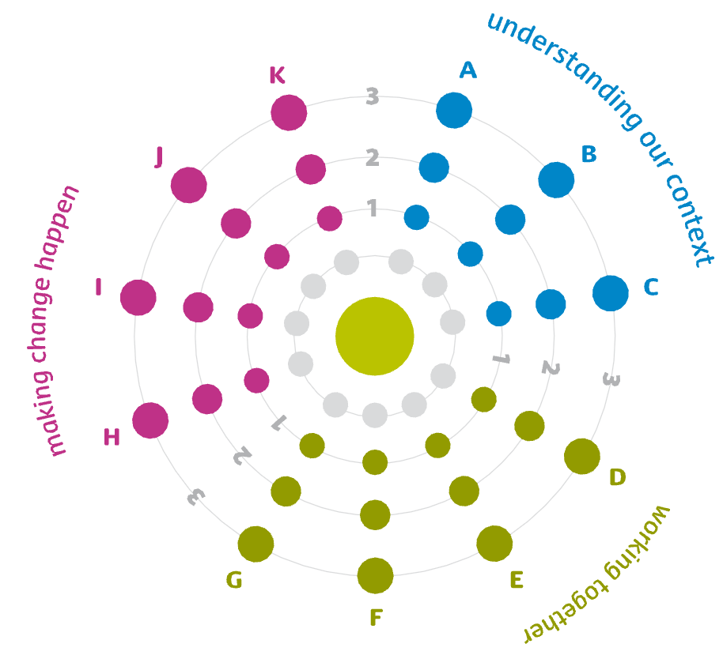

**Levels required for this post**

1. **Being effective**
2. **Excelling**
3. **Leading the way**

**Terms and Conditions**

|  |  |
| --- | --- |
| **Contract** | A two year contract is offered, including a six-month probationary period. |
| **Salary** | Grade 4 : 17,327$US per annum (including 13th month salary) with 12 annual increments, up to 22,090$US. |
| **Hours** | 8am to 4pm five days a week, with one hour for lunch. Some evening and week-ends may be required for which time off in lieu is available |
| **Holidays** | 20 days per year plus 6 days at Christmas and Easter decided upon by CAFOD – 9 days public holiday, so be it 34 days. |
| **Notice period** | Three months either way after completion of the probationary period. |
| **Pensions** | There is an optional contributory pension scheme (10% employer and 5% employee contribution). Alternatively, CAFOD will make a similar contribution to a Personal Pension Plan. |
| **Other benefits** | Medical insurance will be provided for the staff member and spouse plus children 100%.  13th month bonus paid |
| **Access/ Location** | The post will be based in Goma. Goma Office is situated in The BDOM Building on Quartier Les Volcans, avenue du Port Commune Goma |
| **Disabilities** | We are committed to making every reasonable adjustment to the workplace or working arrangements so as to accommodate people with disabilities. |

*CAFOD is an equal opportunities employer. Recruitment and selection procedures reflect our commitment to child protection.*

**Additional information**

**CAFOD**

CAFOD is the official Catholic aid agency for England and Wales. In more than 40 countries across the world, we bring hope, compassion and solidarity to poor communities, standing side by side with them to end poverty and injustice.

Our **vision** is a world transformed to reflect the Kingdom of God: a world where –

* the rights and dignity of every person are respected
* all have access to basic needs in life
* women and men share equally in shaping their societies and our world
* the gifts of creation are nurtured and shared by all for the common good and
* the structures that shape people’s lives are just and enable peace

We work with more than 300 partners overseas, and with partners in the UK - all working to tackle the causes of injustice and poverty. Inspired by Catholic Social Teaching and the experiences and hopes of people living in poverty, CAFOD works for a safe, sustainable and peaceful world.

**International Division purpose**: In collaboration with our partners, to have a lasting impact on poverty and injustice through development programmes, advocacy, and humanitarian response. The division promotes learning, strengthen and empower communities and people in need regardless of their race, gender, religion or politics, and build links between CAFOD supporters and partners overseas.

**Africa Department:** The Africa Department under the leadership of the Head of International Programmes/Africa is divided into teams managed by Regional Directors. There is currently 82 staff in the Department, 8 based in the UK and the remaining working in our international offices in Africa – Nairobi, Harare, Addis Ababa, Kinshasa, Khartoum, Jos, Freetown and Maputo. Nairobi and Harare offices form regional hubs for East Africa and the Horn, and for Southern Africa. In addition, there are a few programme accompaniers based in other countries.

**Programmes Department**

In close co-operation with partners,[1] the Programmes Department is responsible for developing and implementing effective programmes that aim to have a lasting positive impact on poverty and injustice. The Department does this by implementing Just One World (CAFOD’s organisational strategy) in our different working regions, and particularly by putting CAFOD’s partnership principles in practice (partnership standards)[2].

CAFOD’s work in the Great Lakes region focuses on longer term social development programmes in the area of psycho-social trauma, and livelihoods (agro-pastoral activities, youth). In addition to longer term programmes, CAFOD also funds specific programmes in the area of conflict (peace and reconciliation, Sexual and Gender Based Violence including the Governance and Transparency programme), and emergency (caused by conflicts, wars, natural disaster). In order to support CAFOD’s corporate Campaigning work, our advocacy work is a particular focus in the region.

**Team**

The Kinshasa as Country Office, covering our programme work in DRC, including Peace Building programme in Burundi, Rwanda, forms part of the West Africa & Great Lakes Team (WAGL). The WAGL team also work in Nigeria, Sierra Leone, Liberia, with offices in Nigeria and Sierra Leone and in Niger.

The team in the Country consists of;

- A Country Representative (based in Kinshasa),

- The Team in Kinshasa including; a DRC Programme Manager, a PDFO, and a Finance Officer, one driver (all based in Kinshasa);

- A Finance and Office Manager, DRC Programme Manager, Emergency Response Officer, Early Recovery and livelihoods Programme Officer, an Governance and Peace Building Programme officer, a Programme Finance Officer, a Wash and Environment programme Officer, a Capacity Building Programme Officer, a driver (All based in Goma).

**Ad**

1. See CAFOD’s partnership policy
2. As referred to in CAFOD’s partnership policy